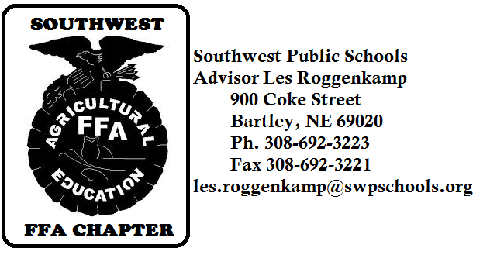
2014-2015 I Believe in the Future of Ag

The Southwest FFA chapter would like to thank you for the financial support that you have provided in past years of the “I Believe in the Future of Ag” campaign. Last year Southwest FFA was able to receive 108% of the local dollars donated to the Nebraska FFA Foundation! This campaign is focused on building capacity for the future of FFA at both the local and state level. Through your financial support the future of agricultural education and the FFA organization will be ensured.

Where does the money go?
Money is collected by the Nebraska FFA Foundation and distributed back to designated FFA chapter. All money designated to the Southwest FFA chapter will be returned to the chapter. All donations will be matched with a proportional share of a $24,000 challenge match pool of funds from corporate sponsors.

How will the money be used?
The Southwest FFA chapter will direct the funds toward the following uses:
  - Leadership Conference for students
  - Community service projects
  - Innovative projects that promote agriculture

How can you donate?
Supporters can donate by going to www.neffafoundation.org or by mailing in the donation card to the Nebraska FFA Foundation.

What recognition is provided?
- All contributors will receive a thank you letter and receipt for tax purposes.
- All contributors will be listed in the booklet of the Nebraska FFA Foundations Annual Report.
- All contributors will be listed on the Nebraska FFA Foundation website.
- All contributors will be named in the Southwest FFA chapter banquet program.
- All contributors will be sent a thank you note from the Southwest FFA chapter.
- All students and parents will be informed of the contributors to the chapter through local media.
(Newspapers, school newsletters, Southwest FFA email and webpage.)

Are donations tax-deducible?
Yes. The Nebraska FFA Foundation is a 501(c)(3) non-profit organization and all donations are tax-deductible as allowed by law. Donors will receive a receipt for tax purposes.

Who can I contact with questions?
Stacey Agnew, Executive Director, Nebraska FFA Foundation. (402) 472-5846 or Stacey@neffafoundation.org
Les Roggenkamp, SW FFA Advisor. (308) 692-3223 or les.roggenkamp@swpschools.org

Thank you so much for your support of agricultural education and the Southwest FFA chapter.
Sincerely,

Les J. Roggenkamp

