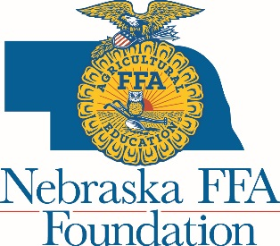
AGENDA
Nebraska FFA Foundation Board
Fall (1st Quarter) Meeting
Tuesday, October 30th
The Leadership Center, Aurora
11am-2pm
Click here to join meeting: https://zoom.us/j/4024725846
Or join by phone: 1 408 638 0968 Meeting ID: 402 472 5846

10:45-11:00 Gathering
11:00 a.m.
- Review agenda/Mission Moment - Kyla
- Review and approval of July board meeting minutes
- Lunch – 11:30 – Walk through buffet and return to room to eat.
- Financial Report (15 minutes each)
  - Review of September financials – Chad Pfeiffer, HBE
  - Review of Updated Sustainable Funding Plan - Shane/Stacey
  - Presentation of Summary of FY17-18 Audit – Les Buckley, Buckley and Sitzman
    - Action Item: Approval of FY17-18 Audit
- Committee Reports - 12:30
  - Corporate Committee - Shane
  - Individual Committee - Lance
- Organization Reports - 12:45
  - Nebraska State FFA Advisor – Amy Tomlinson
  - Nebraska Director for Agriculture Education – Krystl Knabe
  - Nebraska FFA Board – Matt Kreifels
  - Nebraska Agricultural Education Association – Kris Spath
  - Nebraska FFA Alumni Association – Rich Douglass
- Foundation Staff Reports - 1:00
  - Executive Director – Stacey
  - Development and Marketing Manager – Sarah
  - Program Coordinator – Victoria
- Old Business
  - Action Item: By-law update
- New Business
  - Action Item: Transition Plan
  - Action Item: New Policy Approval
  - Action Item: New Development Coordinator Job Description Approval
- Next Board Meeting - January
- Adjourn – 2:00

*Screen and LCD provided by TLC

